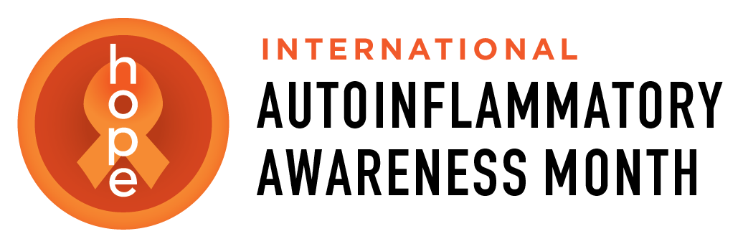
Autoinflammatory Alliance

PO. Box 590354

San Francisco, CA 94159

415-831-8782

karen@autoinflammatory.org

autoinflammatorymonth@gmail.com

Dear (fill in for your town, or for other buildings) City Hall Building Management:

This year for International Autoinflammatory Disease Awareness Month in August, the theme is “Shine a Light on Autoinflammatory Diseases, and we welcome you to help us with this effort, by lighting up ( fill in XXXX City Hall or whatever name of the building) orange sometime in August!

International Autoinflammatory Awareness Month was officially organized and launched in 2015 by the Autoinflammatory Alliance, along with the support of other organizations and our patient community worldwide, to improve understanding and advocate for these rare diseases.

Autoinflammatory Diseases are rare, and more newly defined diseases that affect patients of all ages, often starting in infancy, and affect all races. Earlier diagnosis and treatment can help to change, and even save lives, and there are some treatments that can help, but more research and understanding of these diseases are needed. We’re trying to raise more awareness for these diseases globally, and hope that we can get some buildings to be lit up orange sometime in August to help us to raise awareness around the world! Valencia, Spain and other city halls and companies globally are going to be lighting up orange in August too.

There are virtual patient global events planned for August, and patient organizations worldwide are trying to get buildings lit up orange in August, ideally around August 6-7, 2021 when we are starring our online patient events, but anytime in August is welcome and appreciated, as we have a whole month for awareness. It will mean a lot to patients to have your support, and we will share images of the buildings lit up on social media, and in our patient programs in August.

Patients globally will be helping to “Shine a Light for Autoinflammatory Diseases” wherever they live. They will share images, videos, and stories to share what they want to raise awareness, their hopes and wishes and thanks, which we will also feature on the official International Autoinflammatory Awareness Month website at: https://autoinflammatorymonth.org

We hope that you will join us in helping to “Shine a Light on Autoinflammatory Diseases.” Thank you for your consideration! Please email karen@autoinflammatory.org or call 415-831-8782.

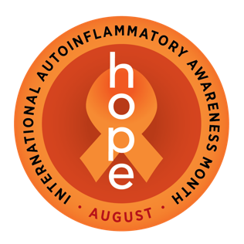
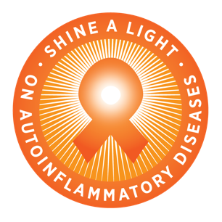
Sincerely,

Signature, or write your name here_________
Your title, contact info (optional)________________

