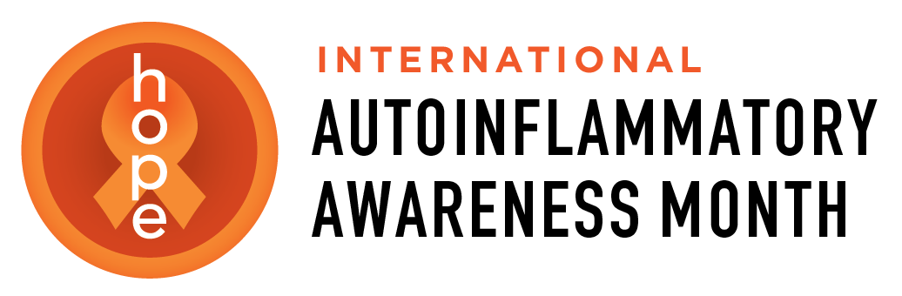
Autoinflammatory Alliance
PO. Box 590354
San Francisco, CA 94159
415-831-8782
karen@autoinflammatory.org
autoinflammatorymonth@gmail.com
[Date]

Dear [Name],

Every August, the global autoinflammatory disease community comes together for International Autoinflammatory Awareness Month. The theme is Shine a Light on Autoinflammatory Diseases.
We welcome you to help us with this effort by lighting up [Name of Landmark] orange sometime in August in support of people living with rare autoinflammatory diseases.
International Autoinflammatory Awareness Month was launched by the Autoinflammatory Alliance in 2015, together with patients, families, advocates, and organizations around the world. Since then, landmarks and public buildings in North America and Europe, including Niagara Falls, Toronto's CN Tower, Boston's Zakim Bridge, Union Station and Children's Mercy Hospital in Kansas City, Gilbert's Water Tower in Arizona, Valencia City Hall, the City of Arts and Sciences, Plaza de España, and Torre del Oro in Spain, have all helped shine a light on autoinflammatory diseases by lighting orange during International Autoinflammatory Awareness Month.
Autoinflammatory diseases are a group of more than 50 rare disorders caused by dysfunction of the innate immune system. They affect people of all ages, often begin in infancy or childhood, and can cause recurrent fevers, severe inflammation, pain, rashes, and other serious symptoms. Because these diseases are rare and often misunderstood, many patients spend years searching for the correct diagnosis and treatment.
Lighting [Landmark Name] orange would help shine a light on these rare diseases, honor patients and families, and increase awareness in your community.
Throughout August, patients, families, caregivers, advocates, organizations, and supporters around the world will help Shine a Light on Autoinflammatory Diseases by sharing stories, photos, educational resources, fundraising efforts, and community events. Your participation would become part of this worldwide effort to increase awareness and bring hope to those affected by these rare diseases.
Thank you for considering our request. We would be honored to share and recognize your participation on the International Autoinflammatory Awareness Month website (https://autoinflammatorymonth.org) and through our social media channels.
Please email karen@autoinflammatory.org or call 415-831-8782 for any questions.

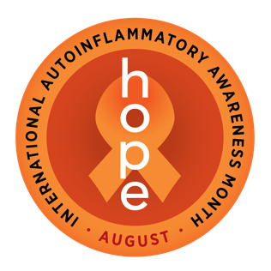
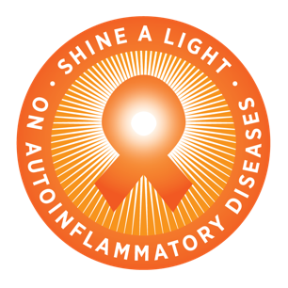
Sincerely,

Signature, or write your name here_________
Your title, contact info (optional)________________

